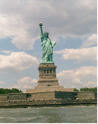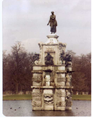

Issue #8 November 2012 Volume #12

Gary Schroeder (55), Editor [gschroeder4@att.net](mailto:gschroeder4@att.net)

Visit the Bushy Park Web Site at <http://www.bushypark.org/>

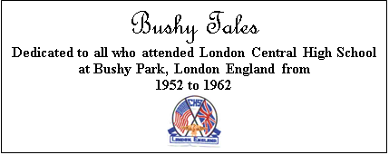

Class Representatives

**1953 - Jackie (Brown) Kenny**

[JKYKNY@aol.com](mailto:JKYKNY@aol.com)

**1954 – Betsy (Neff) Cote**

[betsycote@verizon.net](mailto:betsycote@verizon.net)

**1955 – Nancie (Anderson) Weber**

[nancieT@verizon.net](mailto:nancieT@verizon.net)

**1956 - Edie (Williams) Wingate**

[WingW@aol.com](mailto:WingW@aol.com)



**1957 –Shirley (Huff) Dulski**

[shuffy2@msn.com](mailto:shuffy2@msn.com)



**1958 – Pat (Terpening) Owen**  
[CHS1958@sbcglobal.net](mailto:CHS1958@sbcglobal.net)

**1959 – John “Mike” Hall**

[MGHall@Q.com](mailto:MGHall@Q.com)

**1960 - Ren Briggs**

[rpbjr@frontiernet.net](mailto:rpbjr@frontiernet.net)

**1961 - Betsy (Schley) Slepetz**

[bslepetz@comcast.net](mailto:bslepetz@comcast.net)



**1962 - Dona (Hale) Ritchie**

[DonaRitchi@aol.com](mailto:DonaRitchi@aol.com)



**Roster Changes**

**New Email address:**

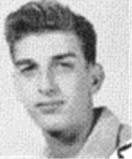

**Walter Costa (55)**

[grtwaldo@gmail.com](mailto:grtwaldo@gmail.com)

Hope your all happy and healthy

  **Look Who We**

**Found**

.

[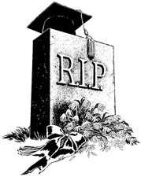](http://www2.free-clipart.net/cgi-bin/clipart/directory.cgi?action=view&link=clipart/Education/Graduation&image=Cap_on_Tombstone.jpg&img=)

**Classmates Who Have Transferred To The Eternal Duty Station**

***Our love and prayers go out to the family and friends of our classmates who have gone on before us. We will miss them, yet we can find comfort in knowing that one-day we will all join them for the greatest of all reunions.***

Although not one of our classmates he was the husband of one of our favorite teachers, Martha Gail Kelly, and she is in our thoughts and prayers.

**Francis Robert Kelly   
1 May 1927 – 25 October 2012**

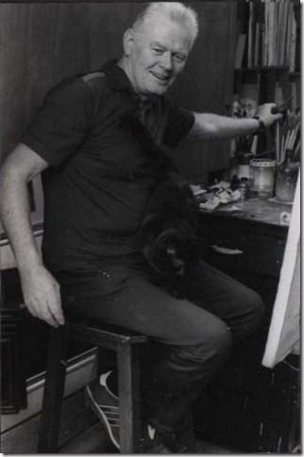

***No flowers, please***

***Donations to Parkinson’s UK, online, via phone or through mail.*** [***http://www.parkinsons.org.uk/support_us/donate/in_memoriam.aspx***](http://www.parkinsons.org.uk/support_us/donate/in_memoriam.aspx)

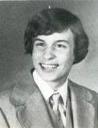

**Sean Kelly (78)**

[sean@us1uk.com](mailto:sean@us1uk.com)

**OBITUARY**

**FRANCIS ROBERT KELLY**

**London-based American artist, author and first American to become President of the Serpentine Swimming Club. Husband of DoDDS Teacher Martha Gail Kelly.**

**Born: 1 May 1927**

**Died: 25 October 2012**

London-based American artist and author Francis Kelly, known for his representational work in figures, landscapes and seascapes, has passed away in his ‘adopted hometown’. He was 85.

Kelly was born in 1927 in St. Paul, Minnesota, to Francis Kelly Sr., a barber, and Agnes Skosheim, a waitress. He lived in Chicago before moving to Santa Monica, California, in his youth.

He enlisted in the US Navy in 1944 towards the end of WWII becoming a signalman and serving in the Pacific until 1948.  It was at the end of the war that he took part in *Operation Crossroads*, the atomic bomb tests in the Pacific during which scientists studied the impact of two separate atomic explosions on ships that had been ringed around Bikini Atoll.

It was art rather than the military that was to prove his true calling. In 1948 he met his wife-to-be and future dependent school teacher, Gail, while sorting post at Santa Monica Post Office No. 1. They married the following year. In 1951 the couple embarked on a journey that first took them to Paris and to the Académie de la Grande Chaumière from where he received his Diploma. In 1953 the couple returned to the US, where he studied at the University of Hawaii, Honolulu, and then back to California where he became laboratory assistant to noted printmaker John Paul Jones at the University of California Los Angeles (UCLA). It was then he briefly worked as a commercial illustrator at Douglas Aircraft.

Awarded a Fulbright Grant in 1955 he came to the Graphics Department of London County Council Central School of Arts & Crafts (now University of the Arts, London) to earn his Diploma in Etching. While he set about taking etching classes when back in England, Gail joined the DODDSEUR /DODDS teaching system first as a substitute and then as a fulltime Art and English Teacher.

The St. George's Gallery in London first introduced Kelly’s etchings in Britain. Over the ensuing years he became increasingly fascinated with the play of shadow and light on what he considered timeless rural lands and byways then not encroached by modern urbanisation.

That stylistic interest also extended to his portrayal of the female figure in both etching and painting media and caught the attention of, among others, world-leading Art Deco expert Victor Arwas and his wife, Gretha, who regularly championed his works over the years at Editions Graphiques in Mayfair.

It was the summers spent on his uncle’s farm in Minnesota that gave him great affinity with the rural areas of England – particularly those around East Budleigh and Budleigh Salterton in Devon where he returned to paint and etch frequently over the years.

In 1966 he was appointed Art organizer for the U.S. Embassy’s "Festival of Arts in Humanities" and his paintings were shown in the exhibition "Five American Artists in Britain" alongside those of Antanas Brazdys, Alfred Cohen and John Hubbard and R.B. Kitaj.

During 1976 he acted in a similar capacity on behalf of arts company Winsor & Newton Ltd., who sponsored an exhibition of American artists commemorating the U.S. Bicentennial.

Kelly also studied painting conservation at the Courtald Institute and in 1967 he was despatched by the Italian Art and Archives Rescue Fund to Florence to restore flood-damaged paintings after the Arno River raged through many of the city’s museums and libraries.   The operation resulted in him writing the seminal book “Art Restoration” It was published by David & Charles in 1971.

Kelly based his home and studio in Bayswater next to Hyde Park which he viewed as his garden. His love of the park, where he could often be found painting or etching his plates, led him to the Serpentine and saw him join the historic open-air Serpentine Swimming Club in 1968. Dressed in distinctive Hawaiian surf clothes designed by his brother-in-law, Kelly was a regular Christmas Day and year-round swimmer who was never afraid to ‘break the ice’. Eventually he would become the club’s first American president from 1983-85.

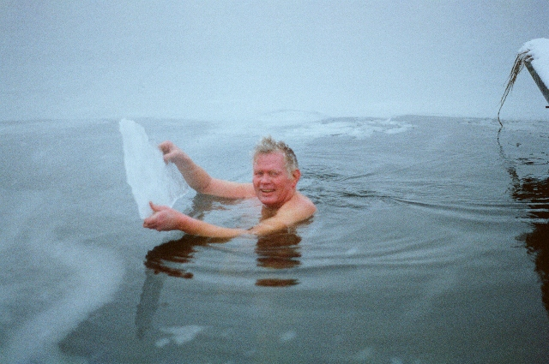

The swimming – and with it biking and running – soon resulted in him becoming involved in triathlons  – eventually managing 34 of them and, even representing Britain as a veteran in the World Triathlon Championships held in Orlando, Florida in the 1980s!

In more recent years Kelly’s attention turned to the reflective qualities of the canals of Venice, Italy, and, also, the effect of weather on posters and bill stickers.

He and his work were featured several times in the *Stars & Stripes* newspaper over the years.

Kelly, died at St Mary’s Hospital in Paddington, London, from pneumonia after a long battle with Parkinson’s Disease and Vascular Dementia. He is survived by his wife, Gail, a retired teacher, and sons Sean (LCHS 79), Duff (LCHS 82) and Jesse (LCHS 84).

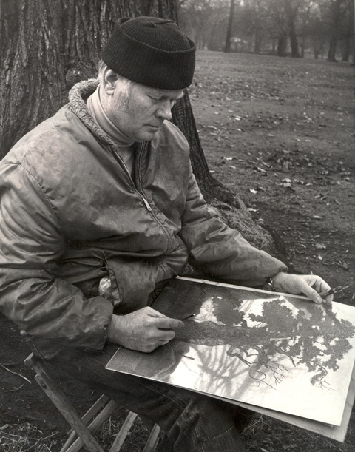

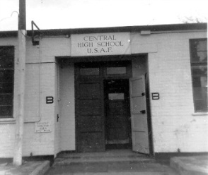

**Memories of Bushy**

**Mike McManis (58)** No picture available

[MMiros@aol.com](mailto:MMiros@aol.com)

To Ellis Young,

I was on the boat trip you referred to.

The girl that "jumped" from the boat was Sandy Mittlestadt. We got into an argument and she just got up and jumped. So much for puppy love.



**Reunion**

**Information**

**Mini**

**Reunions**

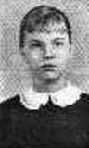**Betsy (Schley) Slepetz (61)**

[bslepetz@comcast.net](mailto:bslepetz@comcast.net)

Mini reunion

 The students from Oslo who went to Bushy (and those who stayed in Norway) are having a mini reunion in the DC area from November 30 to December 3rd.  They include Mary Pace, Judy Ketchew, Hazel Crews, Vinetta Ashmore, Ray Millar, Speedo Thomas, John Clay Buck and myself, all of whom attended Bushy.  We plan to have a grand time reminiscing about the crazy things we did in the dorm, especially on weekends. I will get out my old Vapor Trails and blow the dust and mold off and hope it doesn’t fall apart.  I will update with pictures from now when it’s over.





**Letters to the Editor**

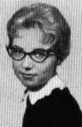**Vicki (Brown) Tidwell (61)**

[d.vtidwell@charter.net](mailto:d.vtidwell@charter.net)

I love getting “Bushy Tales” every month--thank you, so much, Gary.  Haven’t been back to England since I accompanied my husband on a business trip to Birmingham in 2001.  I had to keep pinching myself the whole time we were there.  I attended Bushey Hall for 9th grade, & Bushy Park Central HS for 10th & half of 11th grades ('57-‘59.)  Hubby and I are about to attend our high school reunion for Castleberry High School’s classes of 1961-‘63 at the Fort Worth Stock Yards—can’t wait!  So sad to read that David Grace (aka “Feeb”-class of ‘60) passed away...he was a great guy.  Much love to all my former classmates.

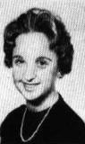**Lydia "Biddie" Ropp Crewdson (62)**

[lydiacrewdson@yahoo.com](mailto:lydiacrewdson@yahoo.com)

I am so sorry I could not be at the reunion in D.C..  My mother broke her hip and I have been Mom sitting for three months in Lexington, South Carolina.

I have told my husband, Bob, for 48 years all about the good times I had riding the train from Teddington to Driffield Air Base in Yorkshire and all of the trains in between.  Bob and I took a trip to England, had the chance to see our home on the base which is not a base any more. Now it is just a little town.  The family who lives in our home invited us in to see it; it had not changed a bit

We also went to where Bushy was suppose to be only to find out it is no more, I was truly disappointed! I love remembering the good as well as the bad times and will always keep the memories in my heart.

Love and prayers to all who were students at Bushy.

Deadline for articles and pictures for the December 2012 issue is November 20th.